Module 3 - Critical Thinking

Miles Exner

Colorado State University Global

Course Code: CS580-1

Instructor: Bingdong Li

Due Date: 3/30/2025

In implementing this TensorFlow linear regression assignment, I encountered several issues including missing fitted lines, exploding loss values, and data type mismatches. These problems were resolved by explicitly converting input data to float32 type, properly initializing model weights to reasonable values, normalizing the input data for numerical stability, and implementing an early stopping mechanism to prevent training divergence.

The final model successfully fitted a linear regression line to the noisy data, with training loss decreasing steadily from approximately 800 to near zero over 200 epochs. The resulting fitted line accurately captured the underlying linear relationship in the data, demonstrating a positive slope that matches the expected trend from the original data generation process. This implementation effectively demonstrates how proper preprocessing, initialization, and training practices can create stable and accurate linear regression models using TensorFlow.

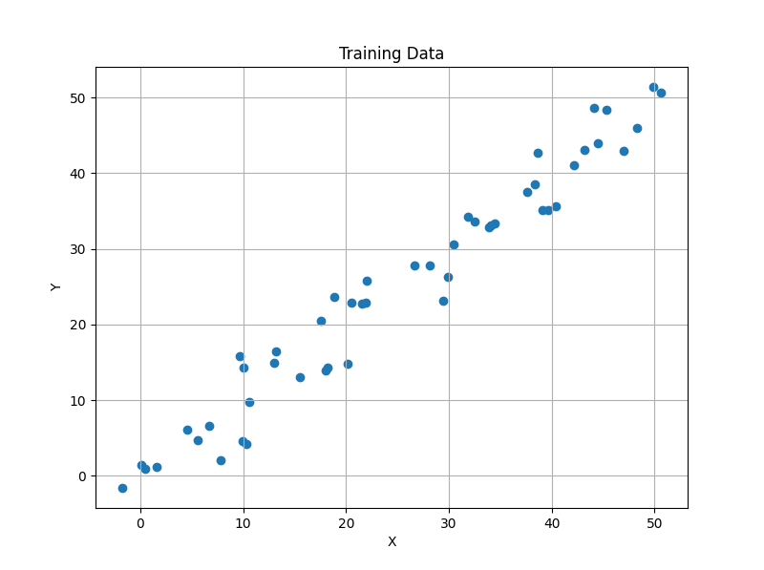

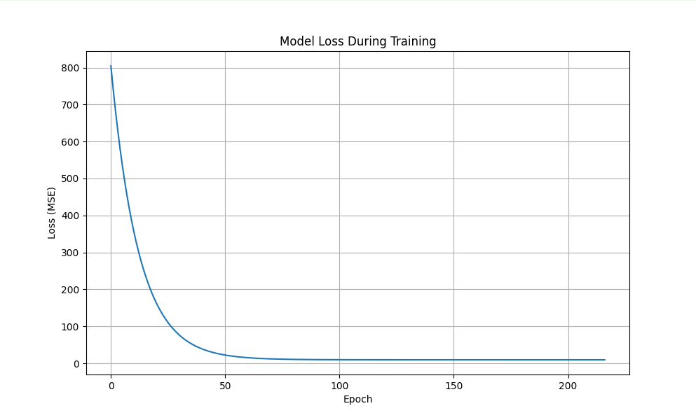

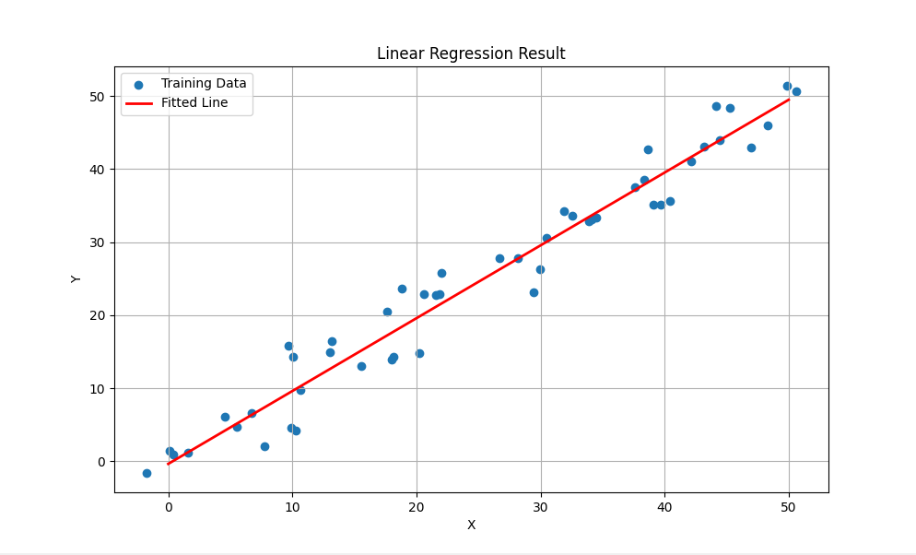

Console output

